7.IR Based Warehousing Bot

Project Description: -
The IR-based Warehousing Bot is an automated material handling system designed for efficient package transportation in warehouse environments. It utilizes IR sensors for navigation, colour detection for zone identification, and RFID for delivery confirmation. This project aims to improve accuracy, speed, and automation in warehouse logistics by reducing manual effort.
The bot consists of a chassis with four IR sensors, two of which are responsible for line following, ensuring smooth movement along a predefined track. The other two IR sensors detect colours on the warehouse floor to determine the correct delivery zone. A robotic arm mechanism, powered by three servo motors, is used to pick up, carry, and place packages. Two servos handle the gripping mechanism, while the third controls the lifting and lowering of the package.
The operation begins when a button is pressed to select the delivery zone (e.g., pressing "A" for red zone). The bot, already holding a package, follows a black guide line until the assigned colour marker is detected. Upon recognizing the designated colour, the bot turns 90 degrees and moves forward until it reaches a black stopping point, indicating the drop-off location. At this point, the robotic arm releases the package, and an RFID scanner verifies the successful delivery.
This project demonstrates an effective and low-cost approach to automating warehouse logistics. It can be used in factories, sorting centres, and smart warehouses to optimize material movement, reduce labour dependency, and minimize errors in package handling. The integration of IR navigation, colour recognition, and RFID validation makes this bot a versatile and scalable solution for industrial applications.

Apparatus: -
S. No. | Component | Description
1. | Microcontroller (Arduino) | Controls the bot’s movements and operations.
2. | IR Sensors (4x) | Two for line following, two for colour detection.
3. | RFID Module (Connected to ESP) | Used for verifying package delivery and sending IoT updates.
4. | ESP 8266 | Handles IoT updates from the RFID scanner.
5. | RFID Tags | Attached to boxes for identification.
6. | Servo Motors (3x) | Two for gripping, one for lifting/lowering the robotic arm.
7. | Chassis | Structure to hold all components.
8. | Motors (2x DC Motors) | Drive the wheels for movement.
9. | Motor Driver (L298N) | Controls the speed and direction of the motors.
10. | Push Button Module | Selects the delivery zone.
11. | Battery (Li-ion/12V) | Powers the bot.
12. | Wheels (2x) | Enable smooth movement of the bot.
13. | Caster Wheel (1x) | Provides balance and stability.
14. | Connecting Wires | Used for electrical connections between components.
15. | LED Indicators (Optional) | Provide visual status updates.

Connections: -
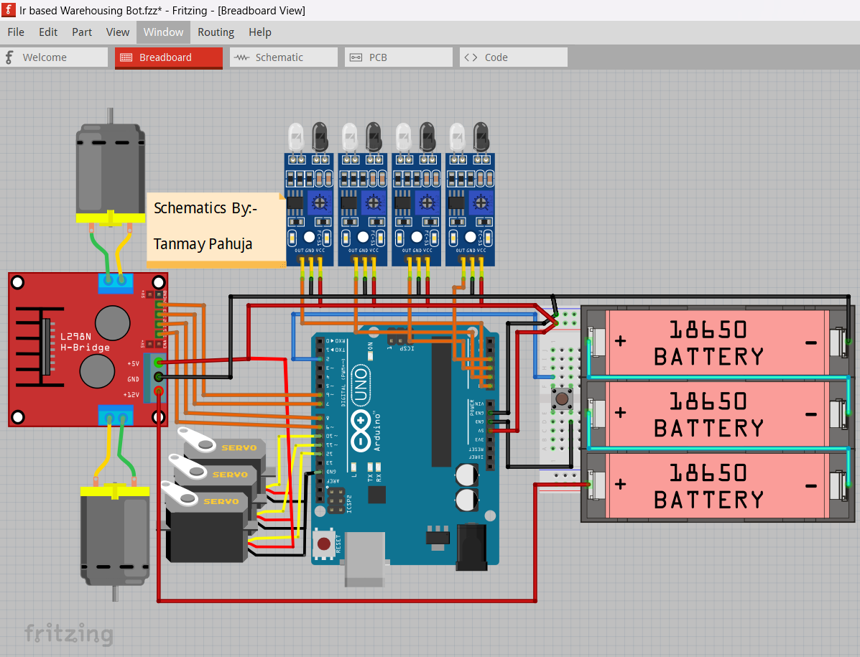
1. IR Sensors (Connected to Analog Pins)
- Left Line Sensor → Arduino A0
- Right Line Sensor → Arduino A1
- Left Color Sensor → Arduino A2
- Right Color Sensor → Arduino A3
2. Motors & Motor Driver (L298N) (No Enable Pins Used)
- L298N IN1 → Arduino D6
- L298N IN2 → Arduino D7
- L298N IN3 → Arduino D8
- L298N IN4 → Arduino D9
3. Servo Motors (Robotic Arm)
- Gripping Servo 1 → Arduino D10
- Gripping Servo 2 → Arduino D11
- Lifting Servo → Arduino D12
4. RFID Module (Connected to ESP for IoT Updates)
- RFID TX → ESP RX (GPIO3)
- RFID RX → ESP TX (GPIO1)
- RFID VCC, GND → Powered by 3.3V/5V
5. ESP Module (Handles IoT updates)
- ESP TX, RX → Connected to RFID Module
- ESP VCC, GND → Powered by 3.3V Regulator
6. Push Button Module (Connected to Digital Pin)
- Button Signal Pin → Arduino D2
- VCC, GND → Powered by 5V from Arduino
7. Power Connections
- Arduino Powered by 5V (Battery/Regulated Source)
- Motors Powered by 12V Li-ion Battery
- ESP Powered by 3.3V Regulator

Code: -
#include <Servo.h>

// Motor Driver Pins
#define IN1 6
#define IN2 7
#define IN3 8
#define IN4 9

// IR Sensor Pins
#define LEFT_LINE_SENSOR A0
#define RIGHT_LINE_SENSOR A1
#define LEFT_COLOR_SENSOR A2
#define RIGHT_COLOR_SENSOR A3

// Servo Motor Pins
#define GRIPPER_SERVO1 10
#define GRIPPER_SERVO2 11
#define LIFTING_SERVO 12

// Push Button
#define BUTTON_PIN 2

// Servo Objects
Servo gripper1, gripper2, lifter;

void setup() {
pinMode(IN1, OUTPUT);
pinMode(IN2, OUTPUT);
pinMode(IN3, OUTPUT);
pinMode(IN4, OUTPUT);
pinMode(BUTTON_PIN, INPUT_PULLUP);

gripper1.attach(GRIPPER_SERVO1);
gripper2.attach(GRIPPER_SERVO2);
lifter.attach(LIFTING_SERVO);

Serial.begin(9600);
}

void loop() {
int leftLine = analogRead(LEFT_LINE_SENSOR);
int rightLine = analogRead(RIGHT_LINE_SENSOR);
int leftColor = analogRead(LEFT_COLOR_SENSOR);
int rightColor = analogRead(RIGHT_COLOR_SENSOR);

Serial.print("Left Line: "); Serial.print(leftLine);
Serial.print(" | Right Line: "); Serial.print(rightLine);
Serial.print(" | Left Color: "); Serial.print(leftColor);
Serial.print(" | Right Color: "); Serial.println(rightColor);

// Line Following Logic
if (leftLine < 500 && rightLine < 500) {
moveForward();
} else if (leftLine > 500) {
turnLeft();
} else if (rightLine > 500) {
turnRight();
} else {
stopBot();
}

// Color Detection & Turning Logic
if (leftColor > 600 && rightColor > 600) {
turn90Degrees();
}
}

void moveForward() {
digitalWrite(IN1, HIGH);
digitalWrite(IN2, LOW);
digitalWrite(IN3, HIGH);
digitalWrite(IN4, LOW);
}

void turnLeft() {
digitalWrite(IN1, LOW);
digitalWrite(IN2, HIGH);
digitalWrite(IN3, HIGH);
digitalWrite(IN4, LOW);
}

void turnRight() {
digitalWrite(IN1, HIGH);
digitalWrite(IN2, LOW);
digitalWrite(IN3, LOW);
digitalWrite(IN4, HIGH);
}

void stopBot() {
digitalWrite(IN1, LOW);
digitalWrite(IN2, LOW);
digitalWrite(IN3, LOW);
digitalWrite(IN4, LOW);
}

void turn90Degrees() {
stopBot();
delay(500);
turnRight();
delay(800);
stopBot();
}

void placeBox() {
lifter.write(90);
delay(1000);
gripper1.write(0);
gripper2.write(0);
delay(1000);
lifter.write(0);
}

Project Outcome: -
The IR-based warehousing bot successfully automates the transportation of goods within a warehouse environment. It follows a predefined black-line track using IR line sensors, ensuring precise navigation. The color detection sensors allow the bot to identify designated drop zones, enabling accurate placement of packages based on pre-assigned locations.
The robotic arm mechanism, consisting of three servos, grips the package securely, lifts it, and places it in the correct storage area upon detecting the appropriate color. The RFID module, integrated with an ESP microcontroller, scans the drop-off location and updates an IoT-based system in real-time, ensuring inventory records remain up to date.
By automating this warehouse operation, the bot reduces manual labor, increases efficiency, and minimizes errors in product sorting and placement. The integration of IoT allows for remote tracking of package movements, making it an ideal solution for modern warehousing and logistics management.

